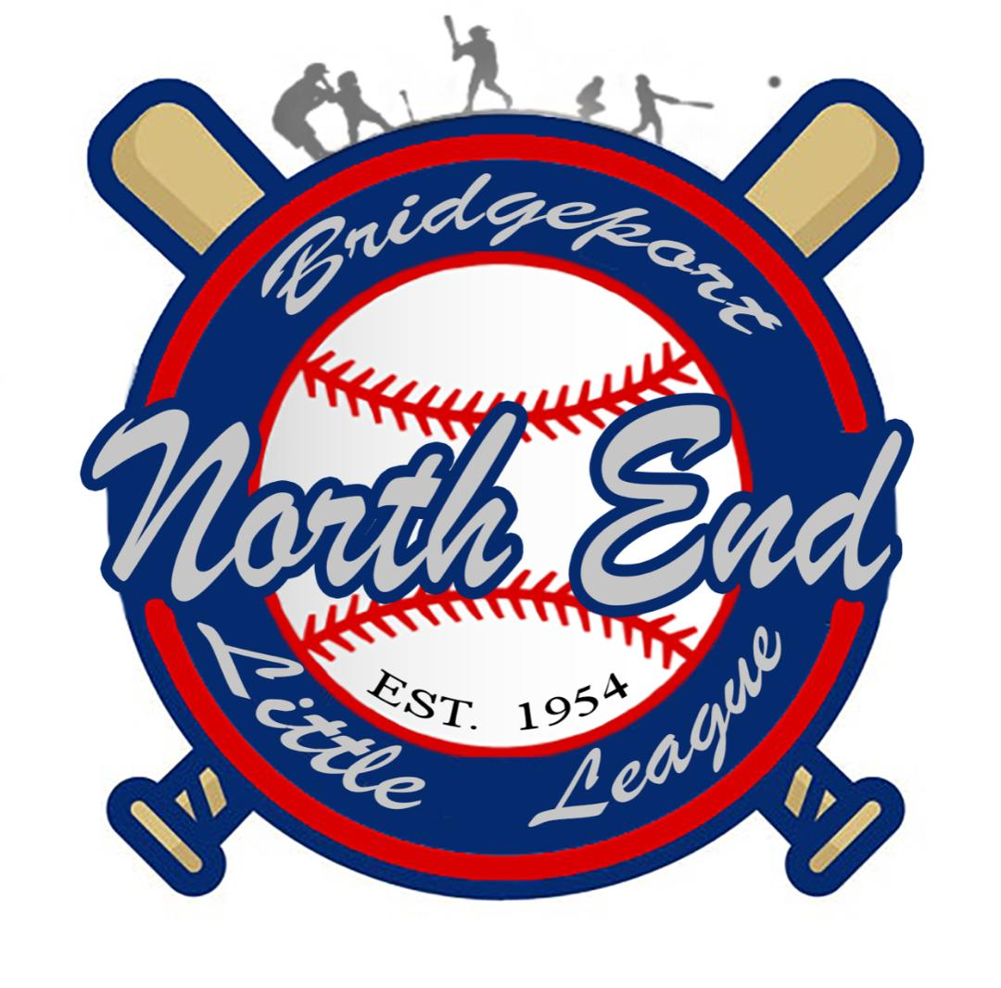
North End Little League
A Chartered League Since 1954
2024 Sponsor Agreement

CONTACT NAME:____________________________________________________________________

BUSINESS NAME:____________________________________________________________________

ADDRESS:__________________________________________________________________________

CITY/ST/ZIP:__________________________________________ PHONE:_ ( ______ ) _____________

EMAIL:________________________________________________ FAX:_ ( ______ ) _______________

WEBSITE:__________________________________________________________

Previous Sponsor_________ New Sponsor_________
____ Corporate Sponsor (“GRAND SLAM”) PACKAGE:
(Banner mounted on all 3 scoreboards, Thank-you plaque, $ 2000.00
3x5 field banner on all 3 fields, advertisement on North End Little League Website
& social media… NEW BONUS THIS SEASON: banners on all 3 fields and an additional
Banner displayed at snack-stand)

____ Team Sponsor (“HOME- RUN”) PACKAGE: $700.00
(Name on team uniform; 3’ x 5’ Sign at field; team plaque,
business banner advertised during opening day ceremony carried by the team during
walk out parade in front of all NELL family and invited city officials and the Mayor.)

C

____ League Sponsor (“DOUBLE”) PACKAGE: $250.00
(3’ x 5’ Sign at Field)

____ All Star (“NO HITTER”) PACKAGE: $600.00
(Name on Parent T-shirts & team plaque)

____ Score Board Sponsor (“TRIPLE”) PACKAGE: Nellbridgeport@yahoo.com * www.nellbpt.com * www.facebook.com/NELLBPT IG:@Northendlittleleague 203-520-7788

(Banner mounted on scoreboard 22”x33”)

____ Social Media Booster (“SINGLE”)PACKAGE:
(Business advertisement on North End Little League Social $ 100.00
Media once a week every Friday during spring season)

____ Donation $________

*All Donations are tax deductible as NELL is a 501 C-3 not for profit organization. Please make check payable to “NELL”

Cash |  | Amount:
Check |  | Check #:
 |  | Collected by:
 |  | Date:

✂ ----------------------------------------------------------------------------------------------------------------------------------------

SPONSOR RECEIPT: North End Little League
Sponsor Name: |  | Sponsor Type:
Check/cash |  | Amount:
Check #: |  | Collected by:
 |  | Date:

Nellbridgeport@yahoo.com * www.nellbpt.com * www.facebook.com/NELLBPT IG:@Northendlittleleague

